Worship With Us

January 23, 2022

Praise Team Matt Hildebrand
Organist Melodie Spare
Pianist RoAnn Fairchild
Deacon of the Week Carl Hildebrand

Please silence cell phones. Thank you.

Please Note: Face coverings are required in the fellowship hall during the worship service, and may also be worn in the sanctuary, if desired. Thank you!

               

WORSHIP THROUGH PRAISE
Prelude
Chorus “Stand in Your Love”
Hymn # 216 “Christ Arose”
Chorus “Battle Belongs”
Chorus “Take My Life”

WORSHIP THROUGH OFFERING
Offertory ARROWS
Children may be dismissed for ARROWS.

WORSHIP THROUGH INSTRUCTION
Scripture Reading Colossians 1:1-2

Congregation at Prayer

Message Pastor Jeff
“The Greeting”

Closing Hymn # 206 “There is a Redeemer”

Postlude

The service is streamed live to the CBC Facebook page.
Nursery Care during the Worship Service 11:00 a.m.
for children from birth through age three
in the room north of the sanctuary
ARROWS

Ages 3 years old – 5th Grade
Upstairs

NAB Missionary of the Week
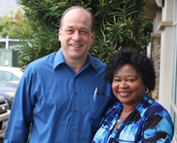

Walter Grob
Cameroon Baptist Convention, Cameroon

Walter began serving with the NAB in Cameroon in 1988 for a three-year assignment; he returned in 1994 and has faithfully served ever since. He handles the missionary finances for the Cameroon Baptist Convention and serves as a resource person for the head of the Finance and Development Department. Pray the continued unrest in Cameroon would come to a peaceful resolution.

CBC Missionary of the Week
Mary Khong
New International, Myanmar

Student of the Week
Hannah Simmons
McPerson College, McPherson, KS

Southwestern Association Pastors of the Week
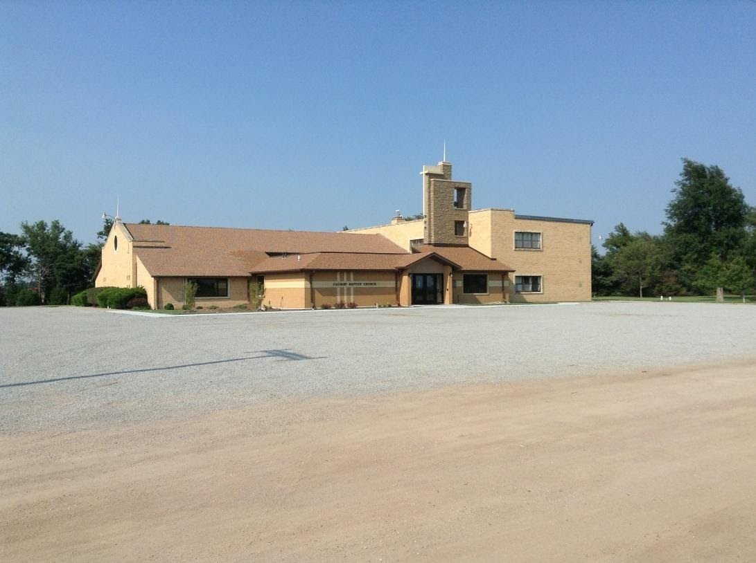
Senior Pastor Jeff Roets
Assoc./Youth Pastor Josh Luevano
Hope Fellowship, Kansas City, MO
Our worship services can be found on
CBC Facebook page, or cbcstafford.org

Today

Sunday School 10:00 a.m.

Adult Sunday School

“The New Testament Canon”
With Dr. Michael Kruger of Ligonier Ministries
Facilitated by Pastor Jeff

CBC Constitution Committee Meeting 7:00 p.m.
At CBC Outreach Center

This Week

St. John CORE – Methodist Church Mon., 5:30 p.m.
Stafford CORE – First Baptist Church Mon., 5:30 p.m.

Men’s Bible Study Mon., 8:00 p.m.
“Building Better Men” by Jarrett Samuels
CBC Outreach Center – Led by Jason Hildebrand

Women’s Bible Study Wed., Jan. 26., 9:30 a.m.
CBC Fellowship Hall—Led by Suzanne Hildebrand & Becky Thrasher

KidZone – Stafford Senior Center Wed., 6:30 - 7:30 p.m.
The Well – at the Annex JH – Wed., 6:30 - 7:30 p.m.
HS - Wed., 7:30 - 9:00 p.m.

Women’s Bible Study Thurs., 7:00 p.m.
CBC Fellowship Hall—Led by Elizabeth Fitch

Plan Ahead

CBC Annual Meeting Sun., Jan., 30, 12:30 p.m.
Following the Worship Service and preceded by a basket dinner in Fellowship Hall. Everyone is invited to this meal together and to consider the continued ministry of Calvary Baptist Church. The meeting will begin around 1:15 p.m., if you would like to join us without attending the basket dinner.

Winter Jam – Intrust Bank Arena Thurs., Feb. 10, 3:00 p.m.
For Middle School and High School youth. Leave from Stafford High School at 3:00 p.m.
Please Pray for:

Presbyterian Manor Assisted Living, Newton, KS
Donna Whitehouse

Leisure Home Family in Stafford – Earline Carnes (Suzanne’s Mom)

Kenwood Plaza in St. John – Zelma Lee Wendelburg

Minneola Nursing Home – Ron and Shirley (Rhonda Huggard’s parents)

Military – Ashlee Burnett (Pastor Isaac’s sister), Remington Walker, Jordan Keenan, Austin Burenheide, Bob Burns, Jr., Kenneth Oden, Bill Hayes, Levi Eisenhour, Jeremy Griffin (Edna’s nephew), Noah Johnson, Ryan Pitts – (Arnold & Alda’s grandson-in-law)

Military deployed – Clint Hitt (Garry & Shirley’s grandson) serving in the Air Force in Japan.

Kristi TenClay – on home assignment

Andy and Sara Wesner Family – Church Planters in Montrose, CO. Their latest update letter is on the fellowship hall bulletin board.

Royce and Sue Baron – ongoing health issues

Afghanistan and its future – Christians, Americans, and innocent others there.

Sam Lowther –. Sam’s bone continues to heal well and more quickly than anticipated from the bone cyst surgery. Thank you for your prayers!

Robert & Janet Murphy – (Tami Brensing’s parents) health concerns.

Mary Hildebrand – pray for healing, energy, and strength

Those dealing with Covid and its complications

Nursery – The nursery is available for children during the worship service. There is a sign-up sheet on the front bulletin board for people to staff this ministry.

Request from CORE
We need clean egg cartons and plastic sacks. Please leave them in the box in the hallway by the kitchen. Thanks.

Reports for Annual Meeting
Please have annual reports turned in to the office by Monday morning. You may email them to cbcvangie@gmail.com

Congratulations
Congratulations to Isaac and Libby Spare, and their families, on their marriage yesterday! May the Lord continue to bless you and your relationship!

News from Our Missionaries
Please see the missionary bulletin board in the fellowship hall for recent greetings, updates, and prayer requests from several CBC Missionaries. There are also Christmas greetings intended for everyone at CBC on the hallway bulletin board.

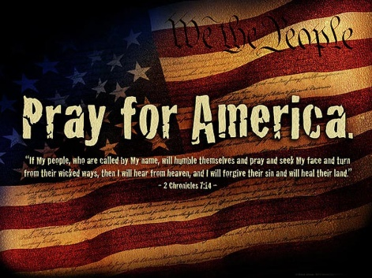

“Grace to you
and peace
from God
our Father.”

Colossians 1:2

Calvary Baptist Church

Stafford, Kansas

January 23, 2022

Senior Pastor Jeff Lowther
Assoc./Youth Pastor Isaac Burnett

Pastor’s Study 620-234-5449

Church Office 620-234-5327

Our Church Website cbcsafford.org

