**Our prayer list for the week – April 19, 2020**

CBC Missionaries of the Week –

**Drs. Dennis & Nancy Palmer - Cameroon**

Student of the Week – **Brittney Schrag**, Kansas State University, Manhattan, KS

SWA Pastors of the Week – **Hope Fellowship**, Int. Pastor Mike Franz, Dir. of Youth, Josh Luevano

**Jose Gomez, Iglesia Bautista Paraiso de Dios in Hayward, California.**

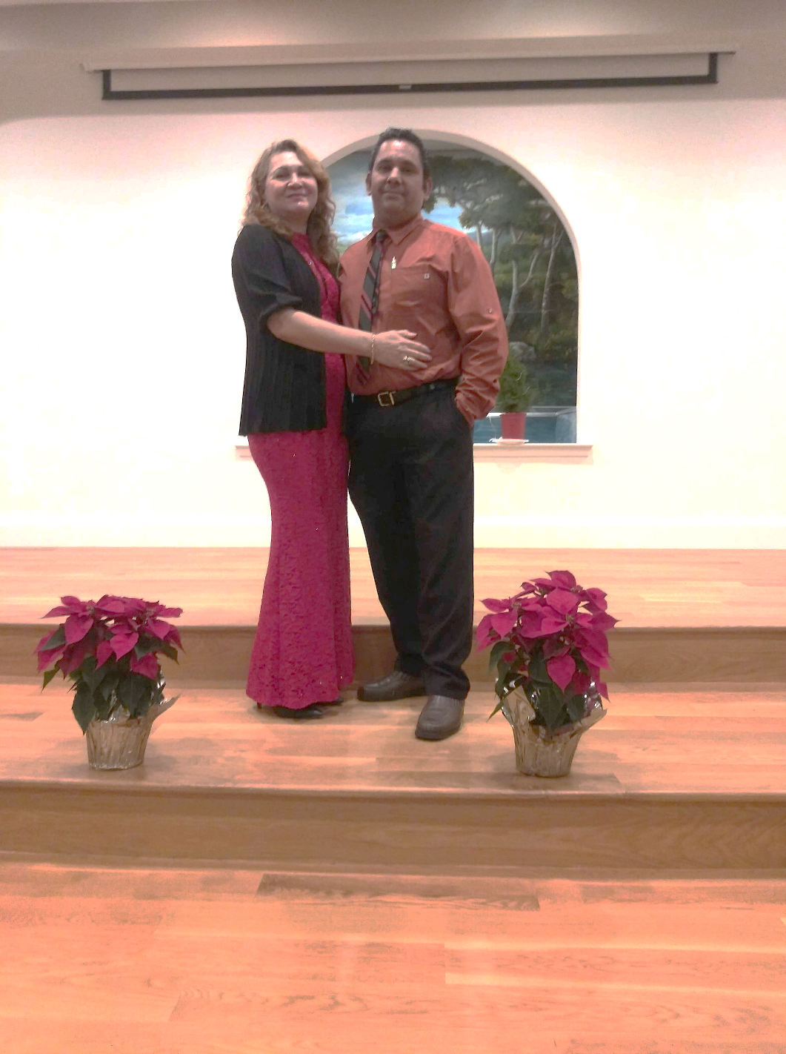After serving in the Bay Area for a number of years, Jose and Juanita Gomez moved to Hayward to plant a church, with a desire that it would be a hub for Latinos all around the Bay Area. Jose says, “Our desire is to make disciples that will follow in the way of Christ, training them to serve, and releasing them to join the Father in the mission of transforming this world through the Gospel of the Son and the work of the Spirit.” The church began meeting in July 2019, and already three people have been baptized. The church is preparing to do an outreach into the community this spring, and Jose has been training people to talk to others about the hope in Jesus. Pray that Iglesia Bautista Paraiso de Dios would be a faithful witness to their community. Pray as well that there would be enough resources and time for the work to be done effectively since Jose is a bi-vocational pastor.



**Our Leisure Home Family Pray for:**

Cheryl Smith **Our country** – government & citizens

Donna Whitehouse **Coronavirus**

Earline Carnes **Cameroon** – the violence, our missionaries

**Merlyn Hartsell** – is in Kansas Heart Hospital in

**Matt & Sarah Zimmerman** – in Hutchinson Wichita recovering from quad by-pass surgery.

**Our Military Deployed** They are encouraged with his progress.

Ryan Pitts, Okinawa **Barkers & PEEI** – health & ministry

Jacob Kershner – Philippines **Ryan & Mary Russell** – in Myanmar

Clint Hitt – South Korea **Royce and Sue Baron** – health & safety in Texas

their ministry in Katy, Texas

**Our Military** **Gay Fritzemeier -** (Joy’s sister)

Remington Walker

Jordan Keenan

Austin Burenheide

Bob Burns, Jr.

Bethany Pike Streeter

Kenneth Oden

Bill Hayes

Levi Eisenhour

Jeremy Griffin

Noah Johnson

Dear friends at Calvary Baptist, Well, anther “coronavirus” week has passed, and I’m thinking it’s going to be hard for some of us to go back to our normal, busy schedules of activities! I’m actually loving all these extra hours at home to work on the new ladies’ Spanish Bible study and get caught up with other things. But I do feel so sorry for all the people who are sick and dying and suffering financially. Your support checks for April arrived yesterday, so once again, we want to thank you for your faithfulness! We trust you are all keeping well, and that this quarantine time is actually proving to be a blessing in your lives, and giving you much more time in God’s presence and the Word! I try to keep contact with my 30+ Bible study ladies via What’s Up, and they’re so good about encouraging and praying for each other, even the new believers!

Love and prayers, Royce and Sue Baron